

CBOE Financial Network

Market Data Dissemination

For

OneChicago Security Futures Products

Vendor Interface Specification

Ver 1.2.0 March 19, 2003
TABLE OF CONTENTS

1.0 INTRODUCTION 5
2.0 GENERAL DESIGN OF DATA DISTRIBUTION NETWORK 5
3.0 TRANSMISSION CHARACTERISTICS 6
3.01 TRANSMISSION BLOCK 6
3.02 SOH AND ETX 6
3.03 US 6
3.04 BLOCK TEXT 6
3.05 BLOCK TEXT FORMAT 7
3.06 DATA FORMAT 7
3.07 CHARACTER SET 7
4.0 MESSAGE HEADER 8
4.01 MESSAGE HEADER FIELD DESCRIPTIONS 8
4.02 EXCHANGE ID 8
4.03 RESERVED 8
4.04 MESSAGE IDENTIFICATION 8
4.05 MESSAGE SEQUENCE NUMBER (MSN) 12
4.06 TIME 12
5.0 MESSAGE FORMATS 13
5.01 LAST SALE 14
5.02 QUOTE WITH SIZE 15
5.03 OPEN INTEREST 16
5.04 UNDERLYING VALUE – LAST SALE 17
5.05 UNDERLYING VALUE – BID AND ASK 18
5.06 END OF DAY SUMMARY 19
5.07 BOOK DEPTH (Full Refresh, Update) 20
5.08 Book Depth Processing Logic 21
6.0 FIELD DESCRIPTIONS 24
6.01 ACTION 24
6.02 ASK INDEX VALUE 24
6.03 ASK QUOTE 24
6.04 ASK SIZE 25
6.05 BID INDEX VALUE 25
6.06 BID QUOTE 25
6.07 BID SIZE 25
6.08 BOOK POSITION 26
6.09 BOOK SIZE 26
6.10 EXPIRATION DATE 26
6.10 HIGH PRICE 27
6.11 INDEX SYMBOL 27
6.12 INDEX VALUE 27
6.13 LAST PRICE 27
6.14 LOW PRICE 27
6.15 NET CHANGE 28
6.16 NET CHANGE INDICATOR 28
6.17 NUMBER OF INDICES IN GROUP 28
6.18 NUM ENTRIES 28
6.19 OPEN INTEREST VOLUME 28
6.20 OPEN PRICE 28
6.21 PRICE 29
6.22 PRICE DENOMINATOR CODE 29
6.23 RESERVED 29
6.24 SECURITY SYMBOL 30
6.25 SESSION INDICATOR 30
6.26 SIDE 30
6.27 UNDERLYING PRICE DENOMINATOR CODE 30
6.28 UNDERLYING STOCK PRICE 31
6.29 VOLUME 31
6.30 VOLUME IN BOOK 31
6.31 YEAR 32
7.0 ADMINISTRATIVE MESSAGES 33
7.01 Administrative Message 33
7.02 Administrative Message Text 33
7.03 Administrative Message Standards 33
8.0 CONTROL MESSAGES 35
8.01 CONTROL MESSAGE SUMMARY 35
8.02 CONTROL MESSAGE DESCRIPTIONS 36
8.03 Start of Day – Category H Type C 36
8.04 Start of Summary - Category H Type E 37
8.05 End of Summary - Category H Type F 37
8.06 End of Day - Category H Type J 37
8.07 Reset Sequence Number - Category H Type K 38

INTRODUCTION

OneChicago has contracted with the Chicago Board Options Exchange (CBOE) to provide dissemination services for all OneChicago (ONE) products. As supplier of the ONE match engine, CBOE is uniquely positioned to provide market data in a most timely fashion available. The infrastructure to support the market data distribution will be known as the CBOE Financial Network (CFN).

This document describes the required formats for communications and output messages to effectively interface with the CFN facilities.

GENERAL DESIGN OF DATA DISTRIBUTION NETWORK

CFN will utilize a TCP/IP multicast protocol for the dissemination of ONE information. CFN transmits variable length blocks having maximum lengths of 1000 characters. The length includes a Block Length Header, text and control characters. The number of messages contained in a block is variable and the end of each message is delimited by a Unit Separator character (US), except for the last record in the block, which ends with an End of Text (ETX) character.

Data available via the CFN IP multicast distribution network includes:

Real-Time Production Data
A copy of each ONE real-time production message is available from each connection to the CFN facility delivered via two distinct multicast data streams.

Pre-Launch Test Data
Prior to the official launch of OneChicago markets test data will be disseminated over CFN production ports. After launch, OneChicago will approve new vendors for interim connections to the production feed from vendor test environments until they are prepared to move to their production environment.

Time Beacon and Retransmission facility
CFN does not anticipate implementing either of these facilities initially. The evolution of market data networks over the past several years has dramatically reduced the number of retransmission requests made by vendors. As the network and user community of CFN expands a needs analysis will be performed to determine the importance of providing these features.

TRANSMISSION CHARACTERISTICS

TRANSMISSION BLOCK

Encapsulated within each IP packet is a transmission block. One type of transmission block is used for all types of messages:

S  O  H | BLOCK TEXT | E  T  X

|<------ TRANSMISSION BLOCK ------->|

A block can have a maximum of 1,000 characters inclusive of text.

SOH AND ETX

The Start of Header (SOH) control character (x01) indicates the beginning of the block, whereas an End of Text (ETX) control character (x03) signifies the end of the block.

US

The Unit Separator (US) control character (x1F) is needed in multiple message blocks to signify the end of the preceding message but not the end of the block.

BLOCK TEXT

The block text can consist of multiple messages. A message is a unit of data that can be processed by the receiving station independently of other data. A message may not span a block boundary.

A message consists of a Message Header, which is of fixed length and format, and a Message Text segment that is variable in length and format. A US character delimits each message, while an ETX character delimits the last message in the block.

BLOCK TEXT FORMAT

The block text consists of multiple messages with each message consisting of a Message Header and, with the exception of certain control messages, message text.

The block text is depicted below:

S  O  H | MESSAGE 1  HEADER  & TEXT | U  S | MESSAGE 2  HEADER  & TEXT | U  S | ~  ~  ~  ~ | MESSAGE n  HEADER  & TEXT | E  T  X
|<---------------- BLOCK TEXT ----------------->|

DATA FORMAT

ASCII filler characters are inserted, as required, in accordance with the following rules:

- Zeros (hex 30) are inserted in Numeric fields. All Numeric fields are right justified, as required.

- Spaces (hex 20) are inserted in Alphabetic fields. All Alphabetic fields are left justified, as required.

- Spaces (hex 20) are inserted in Alphanumeric fields, except Strike and Premium Price Denominator Code fields, which are Zero filled. All Alphanumeric fields are right or left justified, as required.

- Reserved fields will be space filled.

CHARACTER SET

All transmissions are in standard 8-bit ASCII code.

MESSAGE HEADER

The Message Header supplied on each message contains a total of 18 Bytes and conforms in all cases to the following data fields:

EXCHANGE  ID  1 | Reserved  1 | MESSAGE  IDENTIFICATION  2 | MESSAGE  SEQUENCE  NUMBER  8 | TIME  6
|←--------------------- 18 BYTES --------------------→|

MESSAGE HEADER FIELD DESCRIPTIONS

EXCHANGE ID

The Exchange ID field is a 1 Byte, Alphabetic character that identifies the ONE as the initiator of the message:

CODE | VALUE
E | OneChicago, LLC

RESERVED

The Reserved field is a 1 Byte, Alphanumeric character, ASCII space filled field. Field is reserved for future use.

MESSAGE IDENTIFICATION

The Message Identification field is a 2 Byte, Alphabetic upper or lower case character, Space filled field. The first character entered in the Message Identification field identifies the Message Category. The second character entered in the Message Identification field identifies the Message Type. The Message Type character is Space filled to either indicate a specific value, or that a Message Type is not applicable to a specified Message Category.

LOWER CASE CODE | VALUE
m | Last Sale
n | Open Interest
o | End of Day Summary
r | Quote With Size
s | Settlement Price
t | Book Depth Full Refresh
u | Book Depth Update
UPPER CASE CODE | VALUE
C | ADMINISTRATIVE
H | CONTROL
Y | UNDERLYING VALUE MESSAGE

MESSAGE IDENTIFICATION - Message Type (second alpha character):

The following Message Types, all mutually exclusive, apply to Category “m” Last Sale messages.

CODE |  | VALUE
Space Filled | REGULAR | Indicates that the transaction was a regular sale and was made without stated conditions
A | CANC | Transaction previously reported (other than as the last or opening report for the particular contract) is now to be cancelled
B | OSEQ | Transaction is being reported late and is out of sequence; i.e., later transactions have been reported for the particular contract.
C | CNCL | Transaction is the last reported for the particular contract and is now cancelled.
D | LATE | Transaction is being reported late, but is in the correct sequence; i.e., no later transactions have been reported for the particular contract.
E | CNCO | Transaction was the first one (opening) reported this day for the particular contract. Although later transactions have been reported, this transaction is now to be cancelled.
F | OPEN | Transaction is a late report of the opening trade and is out of sequence; i.e., other transactions have been reported for the particular contract.
G | CNOL | Transaction was the only one reported this day for the particular contract and is now to be cancelled.
H | OPNL | Transaction is a late report of the opening trade, but is in the correct sequence; i.e., no other transactions have been reported for the particular contract.
J | REOP | Transaction is a reopening of a contract in which trading has been previously halted. Prefix appears solely for information; process as a regular transaction.
K | AJST | Transaction is a contract for which the terms have been adjusted to reflect a stock dividend, stock split, or similar event. Prefix appears solely for information; process as a regular transaction.
L | SPRD | Transaction represents a trade in two contract months in the same class (a buy and a sell in the same class). Prefix appears solely for information; process as a regular transaction.
M | STDL | Transaction represents a trade in two options in the same class (a buy and a sell in a put and a call). Prefix appears solely for information; process as a regular transaction.
N | STPD | Transaction is the execution of a sale at a price agreed upon by the floor personnel involved, where a condition of the trade is that it reported following a non-stopped trade of the same series at the same price.
O | CSTP | Cancel stopped transaction.
P | BWRT | Transaction represents the option portion of a buy/write (buy stock, sell call options). Prefix appears solely for information; process as a regular transaction.
Q | CMBO | Transaction represents the buying of a call and the selling of a put for the same underlying stock or index. Prefix appears solely for information; process as a regular transaction.
R | BLKT | Block Trade
S | EXPH | Exchange Future for Physical

MESSAGE IDENTIFICATION- Message Type (second alpha character):

The Message Type character for Category “C” Administrative and Category “n” Open Interest messages are Space filled.

The following Message Type values apply to Category “o” End of Day Summary message:

CODE | VALUE
Space filled | Security Futures

The following Message Types apply to Category H Control messages. Refer to Control Message Descriptions section for definition of values:

CODE | VALUE
C | Start of Day
E | Start of Summary
F | End of Summary
J | End of Day
K | Reset Sequence Number

The following Message Types apply to Category “r” Quote With Size messages:

CODE | VALUE
Space filled | Regular Trading
F | Fast Market
R | Rotation
T | Trading Halted
I | Inactive
B | Bid from Specialist Book
O | Ask from Specialist Book
C | Both Bid and Ask from Specialist Book

Note: For codes B, O and C only, in addition to special market conditions, type codes are used to identify the quote as being from the Specialist Book.

The following Message Types apply to Category Y Underlying Value message:

CODE | VALUE
Space filled | Index based on Last Sale
I | Index based on Bid and Ask
C | Closing Spot

Note: Additional Message Category(s) and Message Type(s) will be implemented as required. If Vendors are not prepared to process new Message Category(s) and/or New Message Type(s) when implemented, they should be able to handle them to the extent that they do not impact their normal data processing.

MESSAGE SEQUENCE NUMBER (MSN)

The Message Sequence Number (MSN) is an 8 Byte, Numeric, Right Justified, Zero filled field. All messages are assigned a sequence number. On a per line basis, the MSN on the lines are set to Zero at the start of each day and are incremented by one each time a message (other than a Retransmission or Reset Message Sequence Number message) is transmitted. The following exceptions or special considerations should be noted:

1. Retransmitted messages contain the MSN of the original message.

2. The MSN field in the Message Header of a Category H Type K Reset Sequence Number message contains the number to which the MSN counter is to be reset. This number is either Zero or a number greater than the highest number previously transmitted.

3. The Category H Type C Start of Day message contains a Zero message sequence number.

Should CFN experience a line failure and recovery, the message sequence number for the recovered line(s) is reset to a sequence number greater than the last number transmitted. A sequence reset message will be transmitted prior to resumption of data transmission and will indicate the new sequence number that the receiver should expect.

TIME

The Time (Central Time) field is a 6 Byte, Numeric Character, Zero filled field. Format is (Military) HHMMSS where HH=Hour, MM=Minute and SS=Second. Indicates the Time that a transaction is disseminated. For Retransmissions, the Time will contain the original Time that the transaction was disseminated.

MESSAGE FORMATS

Each message transmitted by CFN consists of a Message Header and Message Text. The particular Message Category and Message Type entered in the Message Identification field of the Message Header determines the format of the text. Message formats are fixed field formats (with the exception of Administrative and some Control messages which have unformatted text). Detailed information on each field specified in every message format is contained in alphabetical order in the Field Descriptions section (section 6.0) of this document.

SUMMARY OF MESSAGE CATEGORIES AND TYPES
CATEGORY(S) | TYPE(S) | MESSAGE DESCRIPTION
a, O | Space filled | REGULAR SALE
a, O | A | CANC
a, O | B | OSEQ
a, O | C | CNCL
a, O | D | LATE
a, O | E | CNCO
a, O | F | OPEN
a, O | G | CNOL
a, O | H | OPNL
a, O | I | AUTO
a, O | J | REOP
a, O | K | AJST
a, O | L | SPRD
a, O | M | STDL
a, O | N | STPD
a, O | O | CSTP
a, O | P | BWRT
a, O | Q | CMBO
a, O | R | BLKT
a, O | S | EXPH
C  D | Space filled  Space filled | Administrative  Open Interest
F | Space filled | Equity and Index
H  H  H  H  H | C  E  F  J  K | Start of Day  Start of Summary  End of Summary  End of Day  Reset Sequence Number

LAST SALE

35 BYTES

The Last Sale message is used to report last sale information.

CATEGORY | TYPE
m | Space filled,  A, B, C, D, E, F, G, H, J, K, L, M, N, O, P, Q, R, S

SECURITY FUTURES  SYMBOL  6 | RESERVED  1 | EXPIRATION  DATE  1 | YEAR  1
|←------------- 9 BYTES --------------→|

RESERVED  9 | VOLUME  6
|←-------15 BYTES --------→|

PRICE  DENOMINATOR  CODE  1 | PRICE  8 | SESSION  INDICATOR  1 | RESERVED  1
|←------------- 11 BYTES --------------→|

QUOTE WITH SIZE

47 BYTES

The Quote With Size message is used to report quote with size information.

CATEGORY | TYPE
r | Space filled, F, R, T, A, B, O, C

SECURITY  FUTURES  SYMBOL  6 | RESERVED  1 | EXPIRATION  DATE  1 | YEAR  1
|←---------------- 9 BYTES ----------------→|

RESERVED  9 | PRICE  DENOMINATOR  CODE  1
|←----------- 10 BYTES -----------→|

BID  QUOTE  8 | BID  SIZE  5 | ASK  QUOTE  8 | ASK  SIZE  5
|←--------------- 26 BYTES ----------------→|

SESSION INDICATOR  1 | RESERVED  1
|←--- 2 BYTES ---→|

OPEN INTEREST

27 BYTES

The Open Interest message is used to report current contract Open Interest as reported by ONE’s clearing agent

CATEGORY | TYPE
n | Space filled

SECURITY  FUTURES  SYMBOL  6 | RESERVED  1 | EXPIRATION  DATE  1 | YEAR  1 | RESERVED  9
|←-------------------- 18 BYTES -------------------→|

OPEN INTEREST  VOLUME  7 | RESERVED  2
|←------------ 9 BYTES -----------→|

UNDERLYING VALUE – LAST SALE

MAXIMUM 67 BYTES

The Underlying Value message is a variable length record and can accommodate a maximum number of 5 Index groups. Each group contains the Last Sale Index Value of a security futures narrow based index.

CATEGORY | TYPE
Y | Space filled

NUMBER OF
INDICES IN
GROUP
2
|← 2BYTES →|

INDEX GROUP #1
NBI  SYMBOL  #1  6 | INDEX VALUE  7
|←----- TOTAL OF 13 BYTES -------→|

(CAN INCLUDE UP TO 5 INDEX GROUPS)

INDEX GROUP #5
NBI  SYMBOL  #5  6 | INDEX VALUE  7

|←----- TOTAL OF 13 BYTES -------→|

UNDERLYING VALUE – BID AND ASK

MAXIMUM 107 BYTES

The Underlying Value – Bid and Ask message is a variable length record and can accommodate a maximum number of 5 Index groups. Each group contains the Bid Index Value and Ask Index Value of a stock index.

CATEGORY | TYPE
Y | I

NUMBER OF
INDICES IN
GROUP

2
|← 2 BYTES →|

INDEX GROUP #1
NBI  SYMBOL  #1  6 | RESERVED  1 | BID INDEX  VALUE  7 | ASK INDEX  VALUE  7
|←------------- TOTAL OF 21 BYTES -------------→|

(CAN INCLUDE UP TO 5 INDEX GROUPS)

INDEX GROUP #5
NBI  SYMBOL  #5  6 | RESERVED  1 | BID INDEX  VALUE  7 | ASK INDEX  VALUE  7
|←------------- TOTAL OF 21 BYTES -------------→|

END OF DAY SUMMARY

103 BYTES

The End of Day Summary messages are transmitted shortly before the Good Night messages. It provides, by symbol, the open, high, low, last, net change and underlying information. If no activity occurred for a security, no End of Day Summary is generated for that security.

CATEGORY | TYPE
o | Space filled

SECURITY  FUTURES  SYMBOL  6 | RESERVED  1 | EXPIRATION  DATE  1 | YEAR  1 | RESERVED  9
|←---------------------- 18 BYTES ----------------------→|

VOLUME  6 | OPEN INTEREST  VOLUME  7 | DENOMINATOR  CODE  1
|←-------------------- 14 BYTES --------------------→|

OPEN  PRICE  8 | HIGH  PRICE  8 | LOW  PRICE  8 | LAST  PRICE  8 | NET CHANGE INDICATOR  1
|←---------------------- 33 BYTES ----------------------→|

NET  CHANGE  8 | UNDERLYING PRICE DENOMINATOR  CODE  1 | UNDERLYING STOCK PRICE  11 | BID  QUOTE  8 | ASK  QUOTE  8 | RESERVED  2
|←----------------------- 38 BYTES ---------------------→|

BOOK DEPTH (Full Refresh, Update)

Variable Length 26 + (17 * NUM_ENTRIES) BYTES

The Book Depth Full Refresh and Book Depth Update messages use the same message format. The messages support efficient transmission of changes to book depth up to a system specified depth - currently set at the top five bid and asks for a product. The bid and ask price entries are the composite for all quotes and orders resting against a product.

CATEGORY | TYPE
t,u | Space filled

SYMBOL  6 | RESERVED  1 | EXPIRATION  DATE  1 | YEAR  1
|←---------------- 9 BYTES ----------------→|

RESERVED  9 | PRICE  DENOMINATOR  CODE  1
|←----------- 10 BYTES -----------→|

SESSION INDICATOR  1 | RESERVED  2
|←---------------- 3 BYTES ----------------→|

BOOK SIZE  2 | NUM ENTRIES  2
|←--------------- 4 BYTES ----------------→|

ACTION  1 | BOOK POSITION  2 | SIDE  1 | PRICE  8 | VOLUME IN BOOK  5
|←--------------- 17 * NUM_ENTRIES BYTES ----------------→|

Book Depth Processing Logic
OneChicago Book Depth data is distributed using an incremental update approach where the entire book depth for a product is sent periodically as a refresh, starting at the beginning of trading (pre-open). Between full refreshes, updates to individual book depth entries are sent.
The Book Depth Full Refresh Message (Message Category = t) contains (2 * BOOK SIZE) book depth entries. The BOOK SIZE top bid prices and the BOOK SIZE top ask prices are sent with an action of "A' - to add. When a full refresh message is received - the buy side and ask side of the book for the product should be deleted, being replaced with the values contained in the full refresh message.
R | Replace | Replace the entry at the corresponding price level

The Book Depth Update Message (Message Category = u) contains 1 to 10 book depth entries. Each book depth entry has an Action associated with it.

A | Add | Add an entry to the buy side or sell side - ordered by price level
U | Update | Update the quantity for a price level
D | Delete | Delete the entry at the corresponding price level

When a user listens on the multicast group they should wait until the first full refresh message per product to start processing. Once the first full refresh is received, then the application should begin to process updates for that product.
Messages are synchronized using a sequence number. The sequence number applies across products - all messages must be consumed for proper sequence number handling to keep the view of the book synchronized between full refreshes.

Example 1 First Full Refresh message of the day

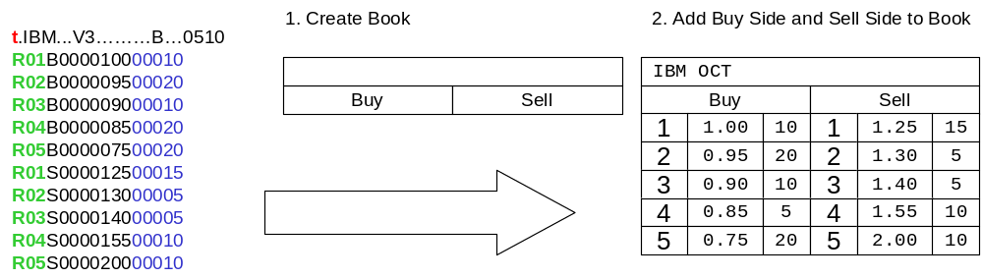

Example 2 Top of the book is traded

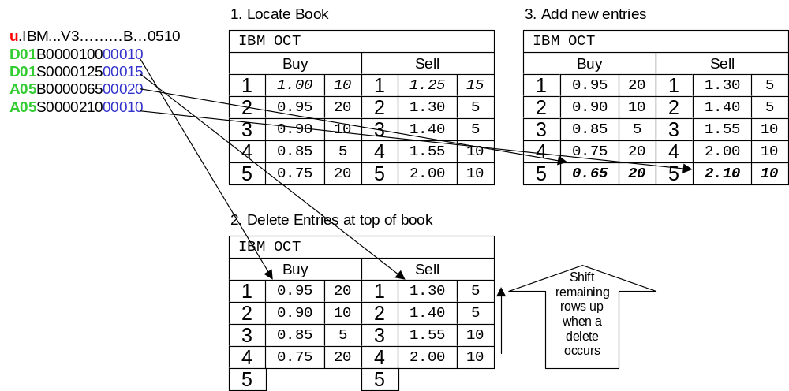
Example 3 Top of the book partially traded

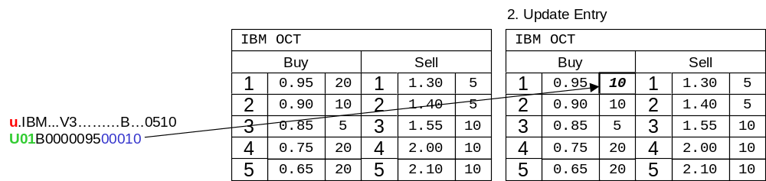

Example 4 New Top of the book entry on both sides

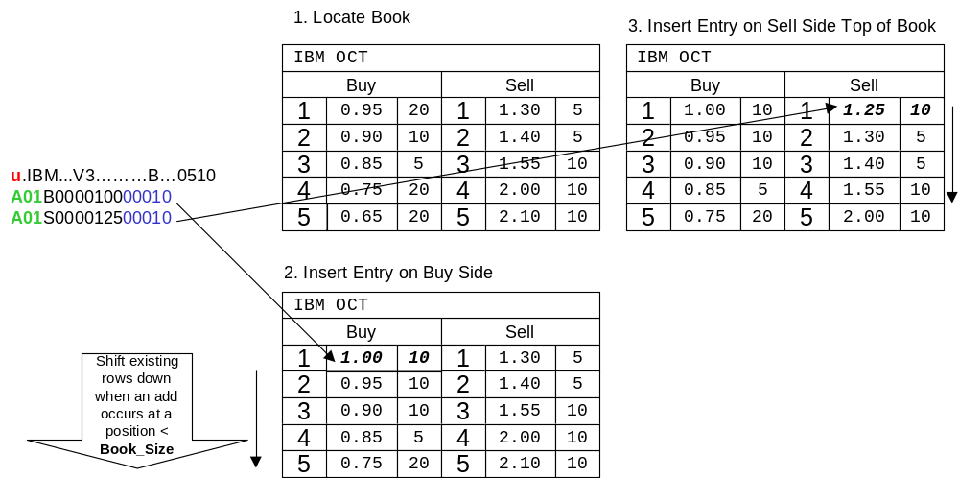

Network Connectivity

OneChicago Book Depth data is distributed using separate CFN multicast groups. The service is designed to be stateless in operation. There is no retransmission capability provided for book depth. There are no control messages on the book depth multicast groups.
Products are distributed alphabetically across multiple multicast groups.
A-E - Multicast Group One
F-N - Multicast Group Two
O-Z - Multicast Group Three

FIELD DESCRIPTIONS

ASCII code characters are defined as follows:

TERMINOLOGY | DESCRIPTION
Alphabetic | ASCII characters “A” – “Z” or “a” – “z”
Numeric | ASCII characters “0” – “9”
Alphanumeric | Any combination of Alphabetic and Numeric as defined above
Special and Punctuation | Any printable ASCII character except Alphanumeric as defined above, i.e.; White Space

- A -

ACTION

1 Byte, Alphabetic. Indicates what action is to be applied with the book entry. Values are:

CODE | ACTION | DESCRIPTION
A | Add Entry | New entry to be added at a position - Subsequent positions are moved down 1 position
U | Update Entry | Update the bid or ask size at a book position
D | Delete Entry | Delete an entry at a location. Subsequent positions are moved up 1 position.
R | Replace Entry | Replace values at a book entry with values provided

ASK INDEX VALUE

8 Bytes, Numeric. Right Justified, Zero filled. When there is no Ask Index Value, this field is Zero filled. The digits to the right of the decimal point represent the numerator of a fraction. The denominator is always represented in 100ths (e.g., 99.99). It may represent a value of Zero or greater.

The Ask Index Value represents the value of the index’s calculation formula using the current ask(ed) values of the component securities.

ASK QUOTE

8 Bytes, Numeric. Right Justified, Zero filled. When there is no Ask Quote, this field is Zero filled.

The 8 Byte Ask Quote is the whole and decimal portion of the Ask Quote price information with the Price Denominator Code determining the location of the decimal point.

Represents the price at which a seller is offering to sell a contract.

When the Ask Quote field is Zero filled, it represents a “No Ask Quote” condition.

ASK SIZE

5 Bytes, Numeric. Right Justified, Zero filled. When there is no Ask Size, this field is Zero filled.

The Ask Size identifies the number of contracts for sale for a contract.

When the Ask Quote and the Ask Size fields are Zero filled, it represents a “No Ask Quote” condition.

- B -

BID INDEX VALUE

8 Bytes, Numeric. Right Justified, Zero filled. When there is no Bid Index Value, this field is Zero filled. The digits to the right of the decimal point represent the numerator of a fraction. The denominator is always represented in 100ths (e.g., 99.99). It may represent a value of Zero or greater.

The Bid Index Value represents the value of the index’s calculation formula using the current bid values of the component securities.

BID QUOTE

8 Bytes, Numeric. Right Justified, Zero filled. When there is no Bid Quote , this field is Zero filled.

The 8 Byte Bid Quote is the whole and decimal portion of the Bid Quote price information with the Price Denominator Code determining the location of the decimal point.

Represents the price at which a buyer is willing to buy a contract.

When the Bid Quote field is Zero filled, it represents a “No Bid Quote” condition.

BID SIZE

5 Bytes, Numeric. Right Justified, Zero filled. When there is no Bid Size, this field is Zero filled.

The Bid Size identifies the number of contracts being bought for a contract.

When the Bid Quote and the Bid Size fields are Zero filled, it represents a “No Bid Quote” condition.

BOOK POSITION

2 Bytes, Numeric. Right Justified, Zero filled.

The Book POSITION specifies where in the book an update action is to take place.

BOOK SIZE

2 Bytes, Numeric. Right Justified, Zero filled.

The Book Size specified the maximum number of book positions (price levels) are being reported. The Book Size is configurable. It is important to be sure your application can handle changes in size of the book.

- E -

EXPIRATION DATE

1 Byte, Alphabetic. It indicates the expiration month for the security future.

CODE | VALUE
F | JAN
G | FEB
H | MAR
J | APR
K | MAY
M | JUN
N | JUL
Q | AUG
U | SEP
V | OCT
X | NOV
Z | DEC

- H -

HIGH PRICE

8 Bytes, Numeric. Right Justified, Zero filled.

The High Price is the whole and decimal portion of the High Price information with the Price Denominator Code determining the location of the decimal point.

Represents the highest price paid for a contract during the trading day.

- I -

INDEX SYMBOL

6 Bytes, Alphabetic. Left Justified, Space filled.

Identifies the unique symbol assigned to an index.

INDEX VALUE

8 Bytes, Numeric. Right Justified, Zero filled. When there is no Index Value, this field is Zero filled. The digits to the right of the decimal point represent the numerator of a fraction. The denominator is always represented in 100ths (e.g., 99.99). It may represent a value of Zero or greater.

Contains the index value using last sale values of index components.

- L -

LAST PRICE

8 Bytes, Numeric. Right Justified, Zero filled.

The Last Price is the whole and decimal portion of the Last Price information with the Price Denominator Code determining the location of the decimal point.

Represents the last price paid for a contract during the trading day.

LOW PRICE

8 Bytes, Numeric. Right Justified, Zero filled.

The Low Price is the whole and decimal portion of the Low Price information with the Price Denominator Code determining the location of the decimal point.

Represents the lowest price paid for a contract during the trading day.

- N -

NET CHANGE

8 Bytes, Numeric. Right Justified, Zero filled.

The Net Change is the whole and decimal portion of the Low Price information with the Price Denominator Code determining the location of the decimal point.

Represents the change in the price of a contract from the closing price of one day to the closing price on the next day.

NET CHANGE INDICATOR

1 Byte, Special or Numeric. Will contain a plus (+) sign, a minus (–) sign or a Zero (0).

Represents the upward, downward or unchanged price movement in a contract’s trades.

NUMBER OF INDICES IN GROUP

2 Bytes, Numeric. Right Justified, Zero filled.

Represents the total number of indices contained in a particular message.

NUM ENTRIES

2 Bytes, Numeric. Values 00-99. The number of book depth entries contained in the message.

- O -

OPEN INTEREST VOLUME

7 Bytes, Numeric. Right Justified, Zero filled.

Represents the total number of outstanding contracts that have not yet reached expiration.

OPEN PRICE

8 Bytes, Numeric. Right Justified, Zero filled.

The Open Price is the whole and decimal portion of the Open Price information with the Price Denominator Code determining the location of the decimal point.

Represents the first price paid for a contract during the trading day.

- P -

PRICE

8 Bytes, Numeric. Right Justified, Zero filled. When there is no Price, this field is Zero filled.

The whole and decimal portion of Price information. The Price Denominator Code determines the location of the decimal point.

Represents the price of a contract, determined in the competitive marketplace, which the buyer pays to the seller for the rights conveyed by the contract.

PRICE DENOMINATOR CODE

1 Byte, Alphanumeric. The Price Denominator Code field indicates the position of the floating decimal point.

Price  Denominator Code | Denominator Value
A  B  C  D  E  F  G  I  H (not defined) | 10  100  1,000  10,000  100,000  1,000,000  10,000,000  (N/A)

- R -

RESERVED

Variable (V) Bytes, Alphanumeric. Reserved fields are Space filled unless otherwise defined.

Fields reserved for future use.

Note: Reserved fields will be redefined and implemented as required. If data recipients are not prepared to process new field(s) when implemented, they should be able to handle them to the extent that they do not impact their normal data processing.

- S -

SECURITY SYMBOL

6 Bytes, Alphabetic. Left Justified, Space filled.

Identifies the unique symbol assigned to the security.

SESSION INDICATOR

1 Byte, Alphabetic, Space filled.

The Session Indicator identifies the session in which the trade or quote originated.

CODE | VALUE
a (lower case) | Morning (A.M.) session
Space filled | Normal session

SIDE

1 Byte, Alphabetic, The side of the book represented by the book entry.

CODE | VALUE
B | Buy side of book position
S | Sell side of book position

- U -

UNDERLYING PRICE DENOMINATOR CODE

1 Byte, Alphanumeric.

The Underlying Price Denominator field indicates the position of the floating decimal point.

Underlying Price  Denominator Code | Denominator Value
A  B  C  D  E  F  G  H | 10  100  1,000  10,000  100,000  1,000,000  10,000,000  100,000,000

Note: The above Price Denominator Codes are based on Equity underlying code information. However, CFN only supports a maximum of 11 BYTES in the Underlying Price Denominator field.

UNDERLYING STOCK PRICE

11 Bytes, Numeric. Right Justified, Zero filled. When there is no Underlying Stock Price, this field is Zero filled.

The Underlying Stock Price is the whole and decimal portion of the Underlying Stock Price information with the Underlying Stock Price Denominator Code determining the location of the decimal point.

Represents the price of the underlying security.

- V -

VOLUME

4 or 6 Bytes, Numeric. Right Justified, Zero filled.

Represents the total number of contracts traded for a contract in one trade, or the total number of contracts traded for a contract for the entire trading day.

VOLUME IN BOOK

5 Bytes, Numeric. Right Justified, Zero filled. When there is no PRICE, this field is Zero filled.

The VOLUME identifies the number of contracts associated at a given price within the book for a contract. The SIDE field determines if the entry is a buy or sell.

- Y -

YEAR

1 Byte, Alphanumeric, Space filled.

Contains the last digit of the expiration year.

ADMINISTRATIVE MESSAGES

Administrative Message

The length of an administrative message is variable. The total length of the entire message cannot exceed 1000 characters, including the SOH character, the Message Header, the ETX character and all characters between those characters.

Administrative Message Text

For most administrative messages, the text section of the Administrative message is transmitted in free format.

Administrative Message Standards

ONEs use Category C Type (Space filled) Administrative messages to transmit market data on nonstandard options that do not fit normal formats.

ADMINISTRATIVE MESSAGE (ADM)
Field Descriptions | Bytes | Character | Details
Product Type | 4 | Alphabetic | SF – Security Future
Filler | 1 | Space
Filler | 4 | Space
Security Symbol | 4 | Alphabetic  Left Justified  Space filled | MSFT
Filler | 1 | Space
Message Type | 3 | Alphabetic | ADM – Admin Message
Filler | 1 | Space
Text | V | Alphanumeric | Market News
This message is an Administrative Message that news regarding MSFT has been disseminated.

REQUEST FOR QUOTE (RFQ)
Field Descriptions | Bytes | Character | Details
Product Type | 4 | Alphabetic | SF – Security Future
Security Symbol | 6 | Alphabetic  Left Justified  Space filled | MSFT1C
Foller | 2 | Space
Message Type | 3 | Alphabetic | RFQ - Request for Quote
Filler | 1 | Space
Request Identifier | 5 | Alphanumeric Left Justified  Space filled | RFQ1(Space)
Filler | 1 | Space
Text | V | Alphanumeric | JUL 2003 500 Contracts

CONTROL MESSAGES

CONTROL MESSAGE SUMMARY

Control messages perform specified system advisory and control functions.

A Control message may be originated by a ONE and transmitted to CFN or to the data recipients, or may be originated by CFN on behalf of ONE for transmission to data recipients or both. The following represents all Control messages that may be originated by CFN or ONE that are sent to all lines:

MESSAGE IDENTIFICATION  CATEGORY TYPE |  | CONTROL MESSAGE
H | C | Start of Day
H | E | Start of Summary
H | F | End of Summary
H | J | End of Day
H | K | Reset Sequence Number

Control messages can consist of the standard Message Header only, or the standard Message Header immediately followed by text. The textual portion of the message is in variable field (free form).

Control messages are not blocked with any other messages.

For all Control messages, the Exchange ID field in the Message Header will contain a character identifying ONE as the exchange originating the message as follows:

CODE | VALUE
E | OneChicago, LLC

ONE or CFN on behalf of ONE can originate Control messages as follows:

EXCHANGE ID  CODE | CONTROL MESSAGE
E | Start of Day
E | Start of Summary
E | End of Summary
E | End of Day
E | Reset Sequence Number

The Reserved field in the Message Header is ASCII space filled.

The first alphabetic upper case character of the Message Identification field in the Message Header contains the Message Category character “H” meaning Control Message. The second alphabetic upper case character of the Message Identification field in the Message Header contains one of the following characters “C,E,F,J or K” designating the particular Message Type.

In textual portions of Control messages, the Exchange Identification identifies the abbreviated name of the referenced exchange or Processor as follows:

Exchange Identification  Abbreviation | EXCHANGE
AMEX | American Stock Exchange
BOX | Boston Options Exchange
CBOE | Chicago Board Options Exchange
ISE | International Securities Exchange
NYSE | New York Stock Exchange
ONE | OneChicago LLC Securities Futures Exchange
OPRA | Options Price Reporting Authority
PCX | Pacific Exchange
PHLX | Philadelphia Stock Exchange

In the free form textual portions of Control messages, where specified, MM=Month, DD=Day, HH=Hour and MM=Minute (The time is Central Time and format is Military).

CONTROL MESSAGE DESCRIPTIONS

Start of Day – Category H Type C

The Start of Day message is transmitted to data recipients at the beginning of the day to signal the start of message processing by CFN and transmission of messages to data recipients.

Test cycle messages can be repeated until shortly before transmission of the Start of Day message.

The Start of Day message will consist of the standard Message Header immediately followed by the textual message:

“START OF DAY”

The Message Sequence Number (MSN) field always contains a sequence number of Zero.

Start of Summary - Category H Type E

The Start of Summary message is transmitted by CFN to signal the beginning of transmission of one or more End of Day Summary messages for ONE.

The Start of Summary message will consist of the standard Message Header immediately followed by the textual message:

“(EXCHANGE IDENTIFICATION) START OF SUMMARY – MMDD HHMM”

example: “ONE START OF SUMMARY – 0102 1000”

The MSN field contains a number one greater than the number of the last message transmitted.

End of Summary - Category H Type F

The End of Summary message is transmitted by CFN to signal the end of transmission of one or more End of Day Summary messages for ONE.

The End of Summary message will consist of the standard Message Header immediately followed by the textual message:

“(EXCHANGE IDENTIFICATION) END OF SUMMARY – MMDD HHMM”

example: “ONE END OF SUMMARY – 0102 1530”

The MSN field contains a number one greater than the number of the last message transmitted.

End of Day - Category H Type J

The End of Day message signals the end of transmission of original data over the lines.

The End of Day message will consist of the standard Message Header immediately followed by the textual message:

“ONE END OF DAY”

The MSN field contains a number one greater than the highest MSN previously transmitted.

Reset Sequence Number - Category H Type K

CFN transmits a Reset Sequence Number message to the data recipients when the sequence numbers on a line require resetting to a number specified in the Message Sequence Number field in the Message Header.

The Reset Sequence Number message will consist of the standard Message Header immediately followed by the textual message:

“SET MESSAGE SEQUENCE NUMBER”

The MSN field contains the number to which the MSN counter is to be reset.

